**Mr. Visca’s: Calculus (sec 5.5)**

**Chpt 5 – Day 6: Trapezoidal & Simpsons Rule**

Using integrals to find area works extremely well as long as we can find the antiderivative of the function.

* Sometimes, the function is too complicated to find the antiderivative.
* At other times, we don’t even have a function, but only measurements taken from real life.

What we need is an ________________________ to estimate area when we __________ find the antiderivative.



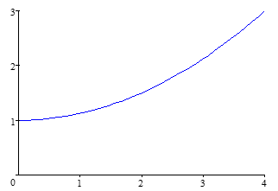

**Find area under curve:**

Solve algebraically and check with calculator

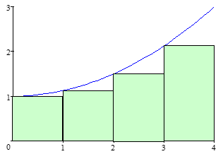

Use LRAM:

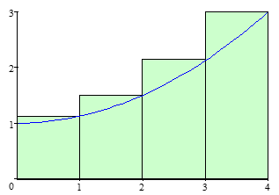

Use RRAM:

Hmmm...LRAM is too low, and RRAM is too high, how about we average them.

Interesting...it's closer.

So, can we draw shapes (not necessarily rectangles) under the curve to represent this calculation above?

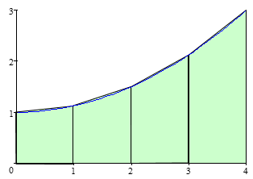



***Ta-daaaaaa!***

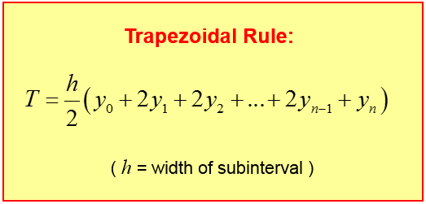

**What about MMRAM?!?:**

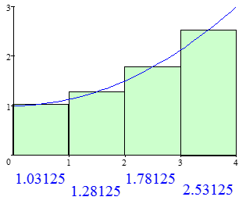

Hmmm...

Trapezoidal Rule is too high, Midpoint (MMRAM) is too low, if only there was a better way???

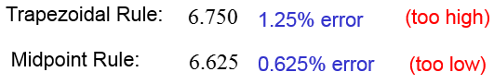

Notice that the trapezoidal rule gives us an answer that has ____________ as much error as the midpoint rule,

but in the opposite direction.

So, let's use a _______________ average!

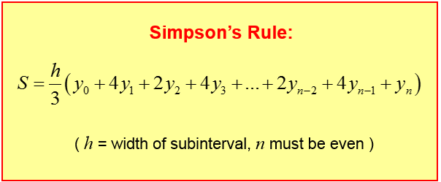

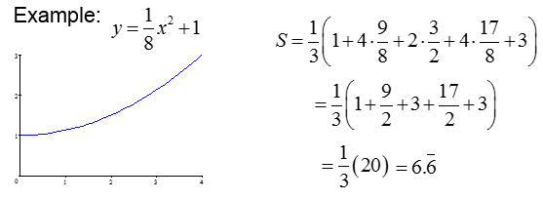

**Homework: section 5.5**

pg. 312-313; 1-7 odd, 10, 13 - 19 odd